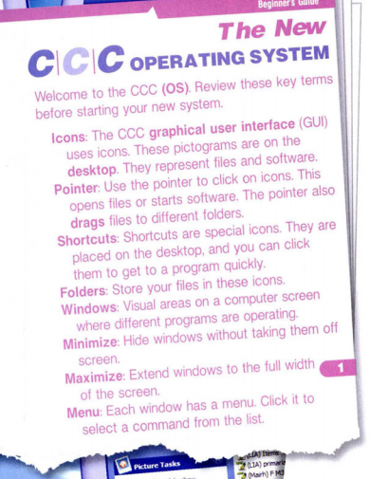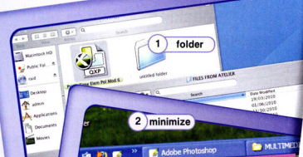

**READING**

**Read the introduction and choose the correct option**

**1what’s the main idea of the passage?**

A-Where to locate the shortcuts

B-the advantages of the CCC OS

C-how to identify and use parts of the OS

D-types of operating systems available

**2 What can you infer about this operating system?**

1. It comes with free software
2. Files have to stay in one folder
3. Menus contain multiple commands
4. Folders do not maximize or minimize

**3 According to the passage, what does the pointer NOT do?**

1. Move files
2. Open menus
3. start software
4. minimize Windows

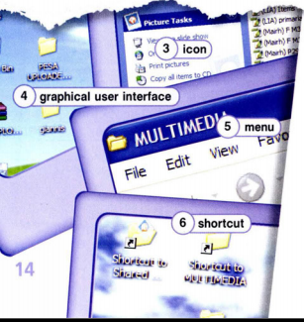

**Vocabulary**

**Fill in the blanks with the correct words and phrases**

**ICONS DESKTOP OPERATING SYSTEM POINTER WINDOWS GUI**

1 Use the …………………………to choose files and commands

2 Small pictures or symbols in software are …………………

3 The ……………is the program that makes a computer work .

4 When something i son the ………………you see it on screen

5 An OS thst uses small pictures to represent files is a …….

6 You can minimize files and programs in different …………

**VOCABULARY**

**CHOOSE THE BEST DEFINITION FOR EACH WORD**

1 DRAG a sabe an icon b close a desktop c move a file

2FOLDERS a organize files b move Windows c create shortcuts

3 SHORTCUT a a type of software b a type of icon c a type of window

**Read and choose a word**

**ADDRESS CHECK CLICK VIRUS BACK UP DRAG EMAIL CRASH**

1-If your computer has a ……………………… ( a software problem) , it may …………………………………(stop working)

because of this you should make a ……………………………….. ( copy)

4 Do you …………………………….(look) your email everyday?

5- What ‘s your email…………………….?

6- You can ……………………….me at maryla@gmail.com

7- Use the pointer to ……………………..on icons and …………………….files

**LISTENING**

**LISTEN TO A CUSTOMER CALLING THE HELP LINE ABOUT THE OPERATING SYSTEM**

1. What’s the dialogue maily about?

A Saving files B Organizing icons C finding shortcuts D locating the folders

1. The customer dos not know where to find the

A icons B desktop C pointer D options menu

**Listen and complete the conversation**

assistant: hello , ccc …………………………….. What do you need …………………………with today?

customer : well , it’s my …………… ………….. i add a …………………………….one day and it ‘s gone the next.

assistant: oh, no problem. just……………………………..them to the ……………………………………

customer: ok, how do i do that?

assistant: first, add the ………………………then ,move the pointer to the …………… ………….. and …………………………”save icons and folders”

customer: options? ……………………………where’s that?

assistant: se the “ccc” …………………….in the corner? ………………… ………………that

customer: got it . thanks.!